Wedding booking form
Customer Name:
Customer Address:

Customer Phone:
Date of wedding
Time of Wedding
Service required ✓ | Details
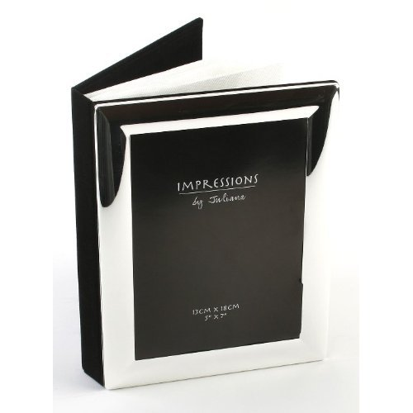  *Bronze  £495 | **Photographer at ceremony and reception venue for cake cutting. Standard range A4 (10x8) 20 photo, album for couple, contact sheet of all photos taken. (Up to 6 hours)
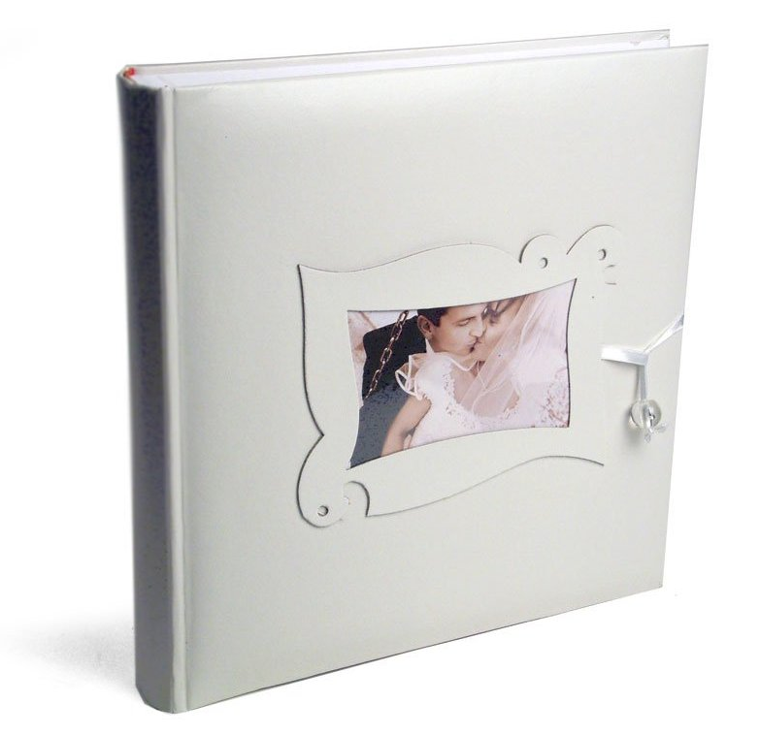  *Silver  £695 | **Photographer at bride’s house, ceremony and reception venue for cake cutting, speeches and dance. Deluxe range A4 (10x8) 20-40 photo, album for couple, 2 x A4 (10x8) Card mounted Photos for bride and groom’s parents, contact sheet of all photos taken.  (Up to 8 hours)
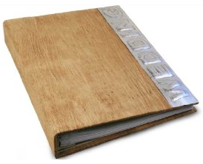  *Gold  £900 | **As above plus: up to 30 A4 (10 x 8) Photos in album. A3 Framed Print for couple, 2 x Mini albums for bride and groom’s parents, CD and contact sheet of all photos taken. (up to 12 hours)
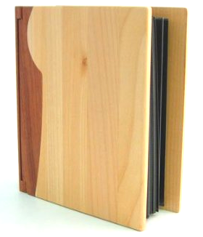  *Platinum  £1295 | **As above plus: up to 40 A4 (10x8) photos in Designer range album 4 x Mini albums for parents, Bridesmaid and Best man. 4 x framed A4 (10 x 8) photos 4 x A3 Framed Prints, CD and contact sheet of all photos. (Whole day)
*Video Production  £400 Per day | 1 HD camera to cover bride’s house preparation, ceremony and reception. 2 x edited DVDs with printed case titles and music.
*2 Camera Video  £600 Per day | As above with an extra camera at groom’s house, 4 x edited DVDs with titles and selected music tracks.
*3 Camera Video  £800 Per day | As above with an extra camera for professional editing, cutaways and special video effects.

Please send completed form and nonrefundable deposit of £100 to:
Mr Karlton Chambers
Nat West Bank Transfer Details:
Sort Code = 60 – 22 – 23
Account Number = 68448619
Hotshots Photographic Services
92 Chingford Avenue, Waltham Forest, London, E4 6RP
Or email completed form to: karlhotshots@gmail.com

***Please note: Additional Travel Expenses must be negotiated for venues outside of M25

Customer Details
Bride’s Name
Address

Tele:
Mobile:
Email
Departure address of bride
Groom’s Name
Address
Tele:
Mobile:
Email
Chief bridesmaid
Tel/Mobile
Names of Bridesmaids/ pageboys
Best Man
Tel/Mobile
Pre-wedding Address
Wedding Ceremony Address
Reception Address
Photo Location if different from above

Please write down any special arrangements, group photos or instructions that you would like for your wedding
The boxes will expand to fit the text as needed (if typed using computer).

Item | Special Instructions/Arrangements
Pre-wedding
Wedding Ceremony
Wedding Reception
Bride’s Family Group (names)
Groom’s Family Group (names)
Other Group photo required

Wedding Photography Agreement between Hotshots Photography services & (bride & Groom)
___________________________________________________________________________
This agreement is between Hotshots Photography, 92 Chingford Avenue, London E4 6RP (Photographer) and (insert names and address of bride and groom) (collectively the “Bride & Groom”) for the purposes of providing photography services between (Insert start and end times) on (Insert Date) at (insert full church address) and between (insert reception times and date) at (insert reception venue full address).
1. Scope of Work:
Photographer shall provide photography services for the Bride and Groom consisting of:
(Insert the name of the wedding package chosen) and (insert any other details) see special instructions sheet for details.
2. Fees:
Photographer shall provide photography services described in the package chosen from the list above for the flat fee of (Insert Price of Package chosen) . Bride & Groom agree to pay to Photographer the partial payment of £100 (One Hundred Pounds Sterling) no later than 14 (fourteen) days prior to wedding date. Bride & Groom agree to pay remaining balance of (insert remaining fee) and any additional expenses as described in clause 3 below, no later than 7 (seven) days after wedding date. In the event that wedding is cancelled by Bride & Groom for any reason, Bride & Groom agree to forego return of the £100 partial payment.
3. Additional Expenses (applicable only to Venues outside London):
Bride and Groom shall pay all food, beverage, and lodging costs for Photographer with a cap of £200 (Two Hundred Pounds). Bride and Groom shall pay for car service for photographer on day of wedding not to exceed £50 (Fifty Pounds).
4. Indemnification:
Bride and Groom shall indemnify and hold harmless Photographer from any loss, damage or liability resulting from Bride and Groom’s violation of the terms of this Agreement or any agreement involving Bride and Groom and the Photographer. Bride and Groom shall indemnify Photographer and hold him harmless from and against any claim by any other person or entity resulting from the performance of his services under this agreement.
5. Assignability and Parties of Interest:
Except as otherwise provided herein, the terms and conditions of this Agreement shall inure to the benefit of and be binding upon the respective successors and assigns of the parties. Nothing in this Agreement, express or implied, will confer upon any person or entity not a party to this Agreement, or the legal representatives of such person or entity, any rights, remedies, obligations, or liabilities of any nature or kind whatsoever under or by reason of this Agreement, except as expressly provided in this Agreement.
6. Independent Contractors:
In providing services pursuant to this Agreement, the Parties shall be independent contractors, and no party to this Agreement shall make any representations or statements indicating or suggesting that any joint venture, partnership, or other such relationship exists between any of the parties except as set forth herein.
7. Entire Agreement:
This Agreement constitutes a single integrated contract expressing the entire agreement of Bride and Groom and Photographer with respect to the subject matter hereof and supersedes all prior and contemporaneous oral and written agreements and discussions with respect to the subject matter hereof, and, except as specifically set forth herein, there are no other agreements, representations, promises or inducements, written or oral, expressed or implied, between the parties hereto with respect to the subject matter hereof.
8. Amendment and Waiver:
This Agreement and each provision hereof may be amended, modified, supplemented or waived only by a written document specifically identifying this Agreement and duly executed by each party. Except as expressly provided in this Agreement, no course of dealing between the parties hereto and no delay in exercising any right, power or remedy conferred hereby or now or hereafter existing at law, in equity, by statute or otherwise, shall operate as a waiver of, or otherwise prejudice, any such rights, power or remedy.
9. Counterparts:
This Agreement may be executed in counterparts. The execution of a signature page of this Agreement shall constitute the execution of the Agreement, and the Agreement shall be binding on each party upon the date of signature, if each party executes such counterpart.
10. Severability:
If any part of this Agreement is determined to be void, invalid, inoperative or unenforceable by a court of competent jurisdiction or by any other legally constituted body having jurisdiction to make such determination, such decision shall not affect any other provisions hereof and the remainder of this Agreement shall be effective as though such void, invalid, inoperative or unenforceable provision had not been contained herein.
11. Clause Headings:
The clause headings in the Agreement are for reference only and do not form a part of this Agreement.

Hotshots Photography Groom and Bride
Signed by: _________________________ Signed by:_______________________
Name: ____________________________ Name 1: ________________________
Date: _____________________________ Name 2: ________________________
Title: Photographer Date: __________________________
Address: 92 Chingford Avenue Address: ________________________
London _______________________________
E4 6RP _______________________________

