Price list:
Please ask about more styles gift ideas and prices

Product Details and options Price
 | 8 x 6 (A5) Photo (with Black Frame)  10" x 8" (A4) photo (with Black Frame)  16 x 12 (A3) photo (with Black Frame) | £10.00  £15.00  £40.00
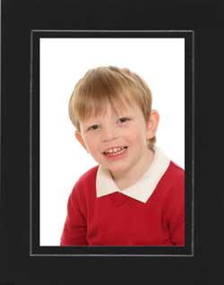 | 8 x 6 (A5) Photo (in Card Mount)  10" x 8" (A4) photo (With card mount) | £5.00  £10.00
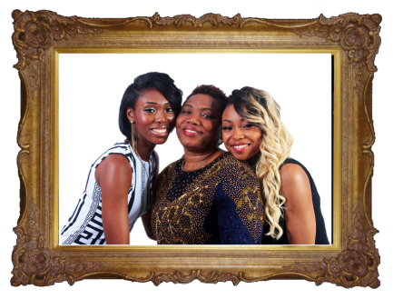 | 8 x 6 (A5) Photo (with Ornate Wood Frame)  10" x 8" (A4) photo (with Ornate Wood Frame)  16" x 12" (A3) photo (with Ornate Wood Frame) | £15.00  £30.00  £50.00
 | 8 x 6 (A5) Photo (with Silver Frame)  10" x 8" (A4) photo (with Silver Frame)  16 x 12 (A3) photo (with Silver Frame) | £10.00  £15.00  £40.00
 | 10" x 8" Canvas Print  Canvas Print (16” x 12")  Canvas Print (20” x 16”) | £15.00  £35.00  £50.00
 | 16 x 12 (A3) photo (Unmounted) | £20.00
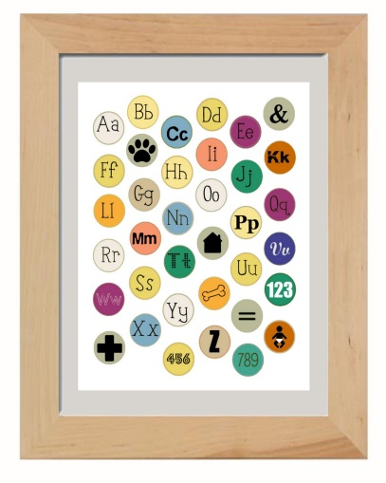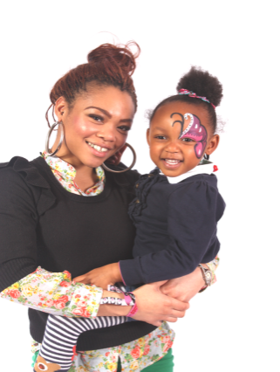  Please ask about our wide range of photo gifts available | 8” x 6” (A5) photo (with Natural Wood Frame)  10” x 8” (A3) photo (with Natural Wood Frame)  16” x 12” (A3) photo (with Natural Wood Frame) | £15.00  £25.00  £45.00
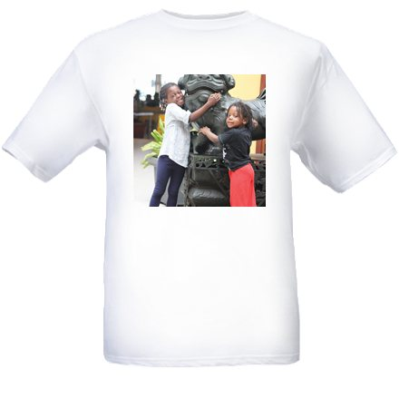
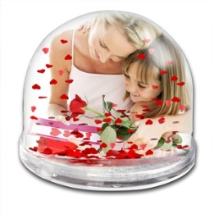
iphone Cases
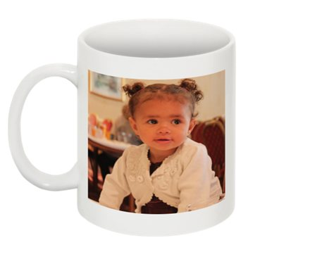
Tee Shirts
Globes, Crystal and acrylic blocks
Mugs

