Portrait Prices
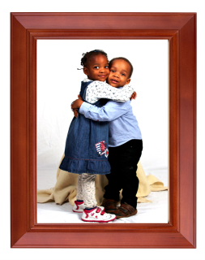
Sitting Fee - £50........Free sitting when you spend over £100
Here are a few of our prices please contact us for a full price list.

Portfolio Prices
Complete Portfolio:
Up to two hours photo shoot plus ten A4 photos in a finished portfolio £195

Print only:
Sitting fee: £50, Free sitting when you spend over £100. Photos on CD are priced at £39.95 each image, this is for a finished image with full copyright to make as many prints as you wish. Discounts are available for multiple prints.

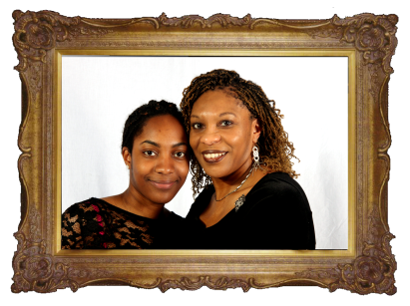
For Hair and make-up artists please call for a quote.
Please Note: Sitting fee of £50 applies to locations within 5 miles of Chingford, for other areas please call for a quote as travelling expenses may be incurred.

Additional Prints Price List
These prices cover any extra prints ordered by you or your family and friends that are not covered as part of a pre agreed package.

Colour Balance May Vary ---- Prices correct at time of publication
Standard Prints  (* mounts not included) |  | Canvas Effect  Framed Prints |  | Canvas Professional Framed Prints
Size | Price | 10 x 8 | £40.00 | 10 x 8 | £55.00
8 x 6 | £10.00 | 11 x 14 | £65.00 | 11 x 14 | £85.00
A4  10 x 8 | £20.00 | 20 x 16 | £95.00 | 20 x 16 | £125.00
A3  16 x 12 * | £30.00 | 20 x 24 | £115.00 | 20 x 24 | £145.00
20 x 16 * | £40.00 | 20 x 30 | £135.00 | 20 x 30 | £165.00
24 x 20 * | £50.00 | Comes with either a gilt or hardwood frame |  | Comes with either a gilt or hardwood frame
20 x 30 * | £60.00
Photographs up to A4 size come supplied in a quality stand-up card mount. Please ask about the full range of Albums, Frames, Photo Books, Acrylic Blocks and other photo gifts and novelty ideas.

Portfolios and family portraits
All that’s required to book our services is a £25.00 deposit (non-refundable) this is payable at time of the sitting and covers the cost of the proofs.
Following your sitting we will provide a set of proofs of your images from which you can choose the photographs you would like enlarged.
Select from our set packages or discuss your individual requirements with our representative.

Star Package - £60
8 - 8 X 6 in mounts
1 - 10 X 8 in mount

Package One - £45
6 - 8 x 6 photographs in mounts.

Package Two - £90
6 - 8 x 6 photographs in mounts
1 - 10 x 8 Canvas print framed in dark wood or gilt.

Package Three - £135
6 - 8 x 6 photographs in mounts.
2 - 10 x 8 photographs in mounts.
1 - 11 x 14 Canvas Print framed in dark wood or gilt.

Package Four - £155
6 – 8 x 6 photographs in mounts.
2 - 10 x 8 photographs in mounts.
1 - 20 x 16 Canvas Print framed in dark wood or gilt.
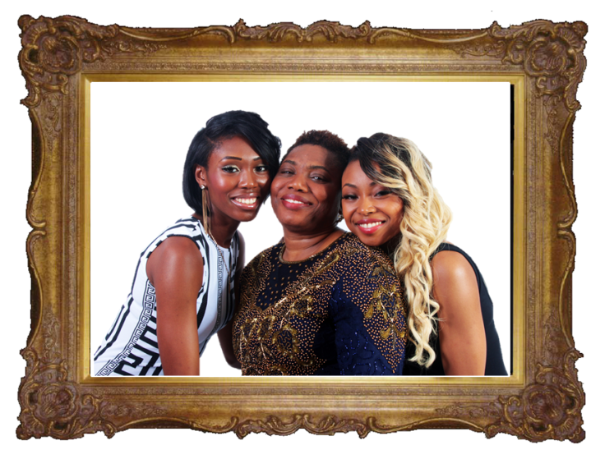
Prices correct at the time of going to print.

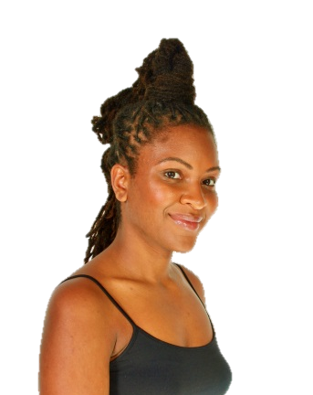
Portfolios
Whether you are looking for a professional portfolio to present to an agency or just a gift, our model makeover will guarantee a stunning and creative set of images.
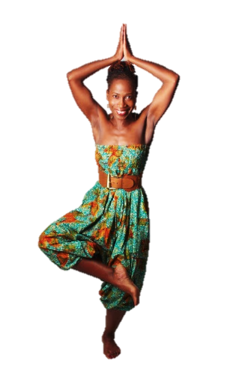
Our makeovers are relaxed and fun. We'll make you look and feel fantastic. We aim to create a lovely set of natural and relaxed pictures showing you at your very best.

We work with highly qualified hair and make-up artists. They will work with you and your wardrobe to create the best effects. You can have a number of outfit changes; this will be agreed at the time of booking. The whole experience can last up to 3 hours depending on the package you choose.
Pre booking is essential.
Gift Vouchers for a Makeover session make an ideal and unique gift for any age group from children through to adults.

The glamour portrait shoot is a more artistic, less formal and more adventurous photo shoot than normal. The type of image you want can be as daring as you feel comfortable with, from sexy outfits, lingerie, topless or artistic nude...you decide.
Gift Vouchers for our glamour session make an ideal and unique gift (must be 18 or over).
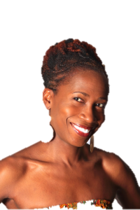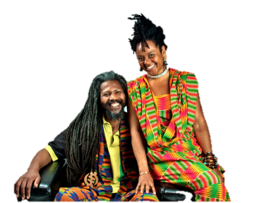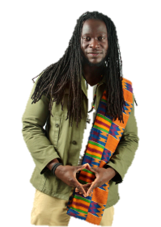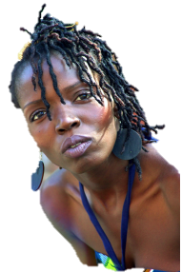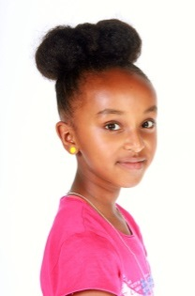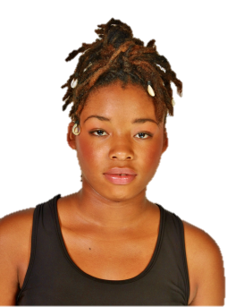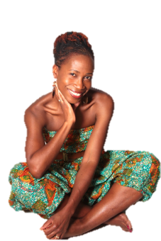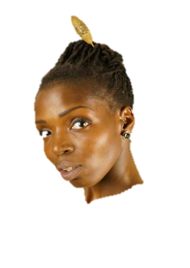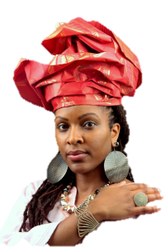

Baby Bumps, Babies and Children
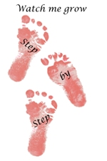
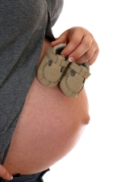
Children grow and change so quickly. Make time stand still and capture these moments, to give yourself and family some loving memories to truly treasure. Children usually relax and react naturally and spontaneously helping us to capture their personality giving unforgettable images.

As a mum to be, you have never looked so lovely. Carrying a child is a magical time so why not let us photograph it and capture some truly unforgettable images.

When is the best time to take your bump picture?
The ideal time for this session should be around 34 weeks pregnant pre booking is essential to avoid disappointment.

Just had a baby? This gives you the perfect excuse to show them off.

Babies grow so fast in the first year of their lives so it's important to record these precious moments with a professional set of photographs. After all, you can't turn back time!
We offer a watch me grow package that’s specially designed for the newest member of the family. We will photograph your baby 3 times in the first 12 months of their lives. This is usually done at 4, 8 and 12 months. Treasure your baby's first year with a fantastic set of portrait prints, a timeless reminder of your baby's first year.

We also offer an optional sitting within the first month of your baby’s life to capture all their precious little details (along with yours), for example their hands in yours, their feet next to yours baby across one arm etc.
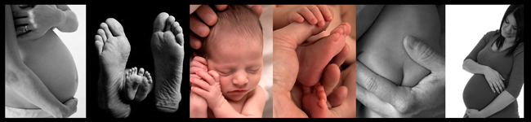

Gift Vouchers
Gift vouchers for a lifestyle portrait session make an ideal and unique gift for any age group, from pregnancy and baby, children through to adults and families, birthdays, christenings, engagements and weddings. On purchase Our Gift Vouchers are sent to the purchaser, so please remember to include your name and address.

Weddings
Having some personalised thank you cards, made with an image of yourselves taken at your wedding on the front is a great and inexpensive way of saying thank you.
Above are examples of two of the cards inside & out, should you choose double sided.

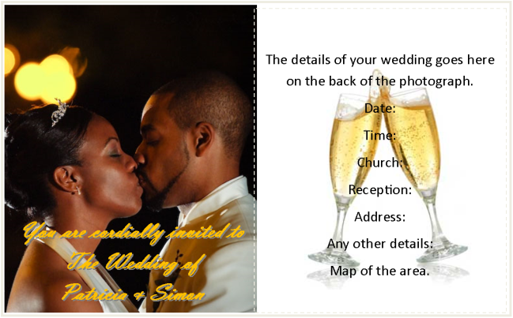
Made from smooth, silk 300gsm A6 white card.
The minimum order is 20 cards.
Single sided £32.00 for 20 that works out to just £1.60 each
Double sided £40.00 for 20 that works out to just £2.00 each.
Prices include envelopes.

Reception photo studio
Imagine your guests' surprise at your reception when they find they can also be the star of the show!
Although your wedding photographers are there for you, the Wedding Reception Studio is there for you and all your guests.
A great way of getting your evening guests into your photographic collection.
Your guests can instantly receive the very highest quality studio portrait prints, complete with mounts, at a fraction of High Street prices!
This is a perfect way for your guests to have a permanent reminder of your big day.
Something that will both entertain during the reception and is also the ultimate personalised gift they will treasure for years to come.
We can take individual payments from guests or if you are feeling generous you can purchase vouchers in advance and include them in your invitations.
Prices on the wedding day
8" x 6" Photo mounted in a card frame £12.
Prices in advance: Packs of ten vouchers £100

We think that our prints are some of the best in the business. We only use the best quality paper. With a beautiful finish and perfect colour reproduction, our prints are priced very competitively. All prints are fully edited by our professional editor.
Prices for prints
15cm x 20cm (6" x 8") ---------------------------£12.00
20cm x 27cm (8" x 10") -------------------------£14.00
30cm x 41cm (12" x 16") ------------------------£24.95
Canvas Prints
These will look stunning on the wall of your home. Your favourite photo mounted onto a wooden frame with a full bleed/gallery wrap effect. The best quality ink and canvas is used to ensure the quality of the photo will last for decades.

Prices for Canvas Prints
12" x 18" - £39.95
16" x 24" -£59.95
DVD Slideshow
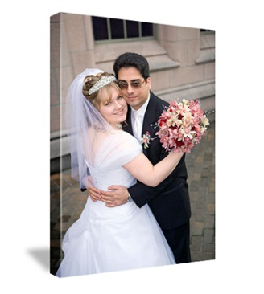
DVD slideshow --------------------------- £100
Duplicate DVD slideshow----------------£45
All copies of DVD's include presentation case
DVD PRESENTATION CASES
Delux
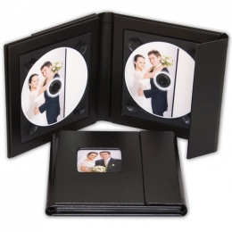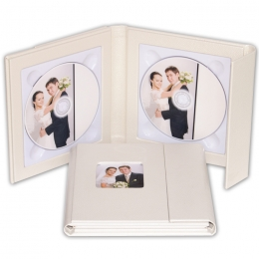
The Deluxe case has a stylish faux leather finish and closes securely with a fold over magnetic flap.
Each case measures 17.5 x 17.5 x 2cm and comes complete with a sturdy and elegant gift box.
The front cover has a 6 x 6 cm photograph cameo
Terms and conditions

'The Client Agreement'

1. Purpose
This agreement contains the entire understanding between the Photographer and the Client. It supersedes all prior and simultaneous agreements between the parties. The only way to add or change this agreement is to do so in writing, signed by all the parties.

2. Reservation
Upon your signature, the Photographer will reserve the time and date agreed upon, and will not make other reservations for that time and date. For this reason, the Reservation Deposit is non-refundable, even if the date is changed or wedding cancelled for any reason, including acts of God, fire, strike, and extreme weather. The Reservation Deposit is to be paid at time of signing the contract. The Reservation Deposit is applied towards the contracted Wedding Package. Client understands and agrees that the entire amount owed for the Wedding Package described in the contract is due on the Outstanding Balance Due date. Client agrees if the balance is not paid by this time, the Photographer will not photograph the Wedding Day described on the contract, with a loss of Reservation Deposit by Client, and no liability to the Photographer.

3. Pre-Event Consultation
The parties agree to a pre-event consultation before the Wedding Day in order to finalise the actual shooting times, locations, and Client’s request list (in writing) for specific photographs. The Client will be responsible for, or have someone designated, to identify people of whom specific photographs are desired. The Photographer will not be held accountable for not photographing desired people if there is no one to assist in identifying people or gathering people for group photographs. The Client agrees to set aside at least 30-minutes of time before the ceremony commencement of the wedding and a 45-minute time frame afterward for photographs that cannot be obtained during the wedding including group shots. If the bride’s or grooms late arrival prevents this 30-minute window from occurring, the Photographer shall not be held liable for failure to take desired photographs.

4. Wedding Party Co-operation
Both parties agree to cheerful co-operation and communication for the best possible result within the definition of this assignment. The Photographer is not responsible if key individuals fail to appear, fail to co-operate during photography sessions, or for failure to capture images due to details not revealed to the Photographer. The Photographer recommends the Client designate an ‘event guide’ to point out important individuals for informal or candid photographs to the Photographer (see above) during the Wedding Day.

5. Shooting Time / Additions
The photography schedule and selected methodology are designed to accomplish the goals and wishes of the Client in a manner enjoyed by all parties. The Client and the Photographer agree that cheerful co-operation and punctuality by all members of the wedding party are therefore essential to that purpose. Shooting commences at the scheduled start time agreed by both parties. Should additional photography and/or travel time, that is not included in the agreed package, be requested by the Client, it will be charged out at the rates specified in the Wedding Package, rounded to the nearest half hour.

6. House Rules
The Photographer is limited by the guidelines of ceremony officials or reception site management. Client agrees to accept the technical results of their imposition on the Photographer. Negotiation with the officials for moderation of guidelines is the Client’s responsibility; the Photographer will offer technical recommendations only.

7. Digital Negatives, Prints and Copyrights
The photographs, digital negatives or prints produced by the Photographer are protected by Copyright Law (all rights reserved) and the Photographer retains the copyright to all photos and images produced. The Client may receive a copy of the digital photographs on a disc, if it has been agreed upon as part of the Wedding Package. If so, the Client may reproduce any images in any manner they like for sharing and enjoyment of friends and relatives. However, the Client must obtain written permission from the Photographer prior to the Client or their friends and relatives publishing or selling the photographs for profit.

8. Model Release
The Client hereby grants to the Photographer and its legal representatives and assigns, the irrevocable and unrestricted right to use and publish photographs of the Client and Guests, or in which the Client and Guests may be included, for editorial, trade, advertising, stock, commercial and any other purpose and in any manner and medium; to alter the same without restriction; and to copyright the same. The Client hereby releases the Photographer and his legal representatives and assigns from all claims and liability relating to said photographs.

9. Exclusivity / Guest Photography
It is understood that the formal photography time is for the express use of the Photographer to capture the formal wedding portraits. Because of time constraints and the need for subjects to give full attention to the professional Photographer, guest photography cannot be permitted during the formal photography time. If time permits, the Photographer will make opportunities throughout the formal photography for guests to take photos. Otherwise, guests are welcome and encouraged to take photos at any time throughout the wedding and reception. The Photographers are to be the only authorised photographers for the day. If this is condition is breeched then photography will be presumed cancelled by the clients.

10. Co-operation of Guests and Other Service Providers
The Client is responsible for the conduct of their guests. Co-ordination with other service providers is necessary to complete all the photography as scheduled. The Client should share the photography schedule with other service providers to make sure that there are no conflicts with times. In addition, events during the wedding day should be planned to make the best use of time for all vendors. The Photographer will not tolerate verbally or physically abusive behaviour, nor will the Photographer share its time or compete with guest photographers for the attention of the subjects. Unchecked guest conduct that interferes with photography will seriously affect the quality of the photographs taken and increase the number of photos that must be created. If the Client is unable to control the conduct of their guests or if the conduct of any of their guests damages any of the equipment of the Photographer, it will result in the early or immediate departure of the Photographer. The Client understands that in such an event, no refund will be given.

11. Completion Schedule
The Photographer will deliver the CD and DVD slideshow within three weeks of the date of the wedding. Albums will be delivered within six weeks of approval by client.

12. Payments
The Client agrees that the Reservation Deposit is required at the time of signing the contract and the Outstanding Balance is due on the Outstanding Balance Due date in the Wedding Package Summary.

13. Penalty Fees & Charges
There is a £10.00 charge for payments returned by the bank for any reason.

14. Limit of Liability
In the unlikely event of severe medical, natural, or other emergency it could be necessary to retain a different photographer. The Photographer will make every effort to secure a skilled replacement photographer. If the situation should occur and a suitable replacement is not found, responsibility and liability is limited to the return of all payments received for the event package. The Photographer takes the utmost care with respect to exposure, transportation, and processing the photographs. However, in the unlikely event those photographs have been lost, stolen, or destroyed for reasons within or beyond the Photographer’s control, the Photographer’s liability is limited to the return of all payments received for the event package. The limit of liability for a partial loss of originals shall be a prorated amount of the exposures lost based on the percentage of total number of originals.

15. Non-Guarantee
Although every possible care will be taken to produce photographs of all important and special moments during the wedding, the Photographer cannot place an unconditional guarantee on the above. The Photographer will not be held responsible for any ruined photographs due to guests’ (or any other) flashes; or any other ruined photographs due to any other cause in or outside of the Photographer’s control.

16. Performance
The performance of this contract on behalf of the Photographer shall be contingent upon acts of God, flood, fire, warfare, government laws or regulations, electrical failure, strikes by suppliers, and / or conditions beyond its control.

17. Severability
If any provision of this agreement is held to be invalid or unenforceable under the law, the validity of this agreement as a whole shall not be affected, and the other provisions of the agreement shall remain in full force and effect.

18. Amendments
This contract has been freely negotiated and shall be recognised as the entirety of the agreement, and only those changes or modifications specifically placed in writing, attached, signed and dated by the Client and the Photographer at the time of this signing shall be recognised as amendments to this contract.

19. Reprint Orders
If a disc of the digital photos is not part of the agreed Event Package, reprints (or additional prints) of photos and other products may be ordered by the Client and/or Guests, through the Photographer, or Online Photo Gallery, if included in the package, at listed prices.

20) Editing
Full editing and retouching will only be done on images chosen for the album. The photographer will design and specially edit an unspecified number of photographs with will be for sale on the website and may also be chosen free of charge for the album.

21) Provision must be made for a meal for your photographers.
Your photographers will still be working whilst taking this meal so will need to be separate from your guests.

Signature (Bride): __________________________________________________________________

Name: _________________________________________________________ Date: _____________

Signature (Groom): ________________________________________________________________

Name: _________________________________________________________ Date: _____________

Signature (Photographer): __________________________________________________________

Name: _________________________________________________________ Date: _____________
I have read and understood the terms above. I hereby agree to the terms of this agreement.

